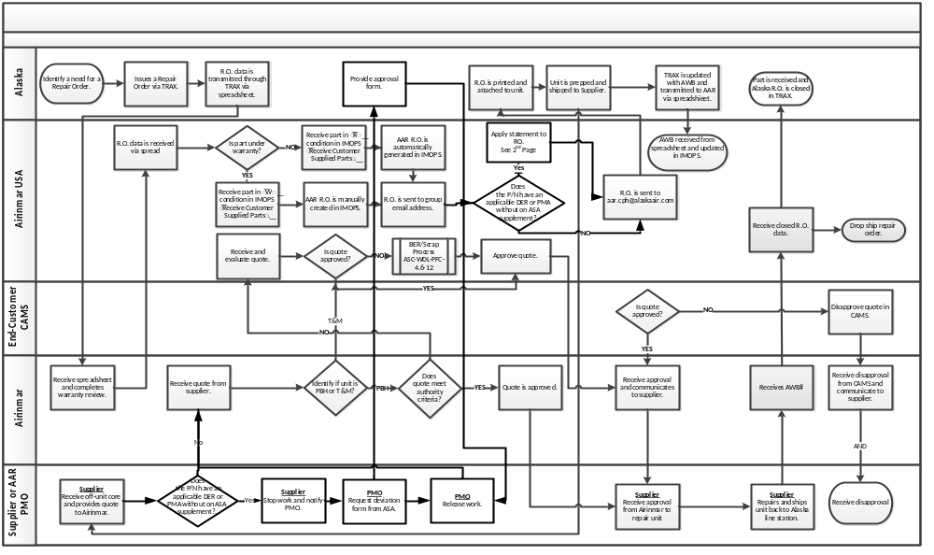

Statement on Repair Order: “ If XXXX (DER / PMA Name) is applicable stop work and e-mail AAR PMO for further instructions and proper documentation to apply XXXX (DER/PMA Name)”

